Regional Internet Registries

🌐 What Is Regional Internet Registries?
# Source: AI Source: Provided by: [Data Path: Persons Table -> ID Column: 1, Name_En Column: Motasem Essam] -> From: [ChatGPT] on [1/16/2026]
Regional Internet Registries (RIRs) are nonprofit organizations responsible for managing the allocation and registration of IP addresses and Autonomous System Numbers (ASNs) within specific geographic regions.

🧠 Simple Definition:
# Source: AI Source: Provided by: [Data Path: Persons Table -> ID Column: 1, Name_En Column: Motasem Essam] -> From: [ChatGPT] on [1/16/2026]
RIRs are organizations that distribute IP addresses and AS numbers to ISPs, companies, and other organizations in different parts of the world, ensuring fair and efficient use of internet resources.

🌎 The 5 RIRs and Their Regions:
# Source: AI Source: Provided by: [Data Path: Persons Table -> ID Column: 1, Name_En Column: Motasem Essam] -> From: [ChatGPT] on [1/16/2026]
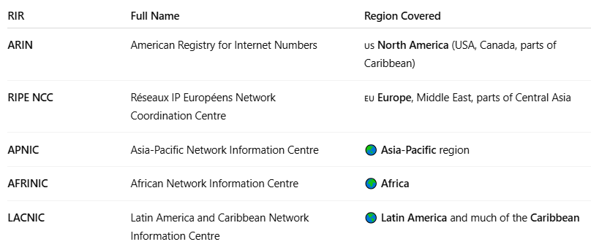

RIR | Full Name | Region Covered
ARIN | American Registry for Internet Numbers | 🇺🇸 North America (USA, Canada, parts of Caribbean)
RIPE NCC | Réseaux IP Européens Network Coordination Centre | 🇪🇺 Europe, Middle East, parts of Central Asia
APNIC | Asia-Pacific Network Information Centre | 🌏 Asia-Pacific region
AFRINIC | African Network Information Centre | 🌍 Africa
LACNIC | Latin America and Caribbean Network Information Centre | 🌎 Latin America and much of the Caribbean

🔧 Responsibilities of RIRs
# Source: AI Source: Provided by: [Data Path: Persons Table -> ID Column: 1, Name_En Column: Motasem Essam] -> From: [ChatGPT] on [1/16/2026]
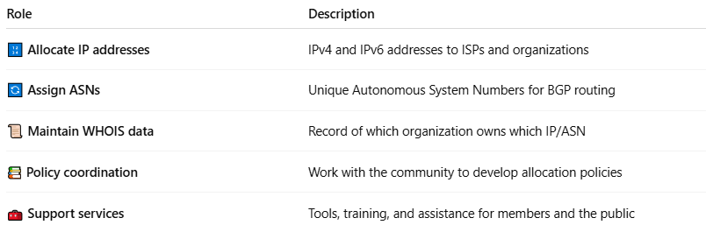

Role | Description
🔢 Allocate IP addresses | IPv4 and IPv6 addresses to ISPs and organizations
🔄 Assign ASNs | Unique Autonomous System Numbers for BGP routing
📜 Maintain WHOIS data | Record of which organization owns which IP/ASN
📚 Policy coordination | Work with the community to develop allocation policies
🧰 Support services | Tools, training, and assistance for members and the public

🧩 IP Address Allocation Hierarchy
# Source: AI Source: Provided by: [Data Path: Persons Table -> ID Column: 1, Name_En Column: Motasem Essam] -> From: [ChatGPT] on [1/16/2026]
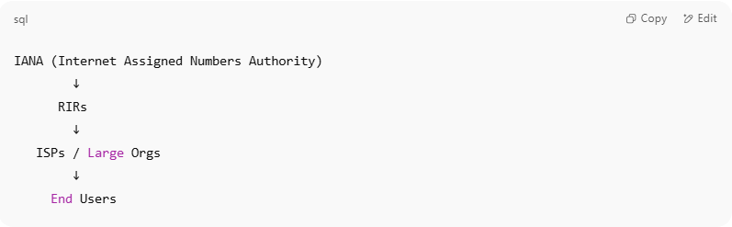

IANA (Internet Assigned Numbers Authority)
↓
RIRs
↓
ISPs / Large Orgs
↓
End Users

- IANA is managed by ICANN and delegates blocks of IPs to RIRs.
- RIRs then distribute IPs and ASNs to ISPs, telecoms, data centers, and enterprises.

🔐 Example WHOIS Lookup
# Source: AI Source: Provided by: [Data Path: Persons Table -> ID Column: 1, Name_En Column: Motasem Essam] -> From: [ChatGPT] on [1/16/2026]
If you look up IP 8.8.8.8 (Google DNS), the WHOIS entry will show:
- IP Owner: Google LLC
- ASN: AS15169
- Managed by: ARIN

✅ Summary
# Source: AI Source: Provided by: [Data Path: Persons Table -> ID Column: 1, Name_En Column: Motasem Essam] -> From: [ChatGPT] on [1/16/2026]
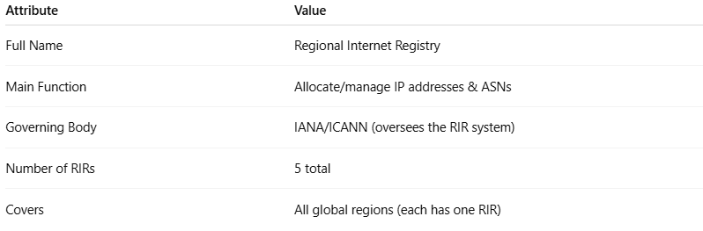

Attribute | Value
Full Name | Regional Internet Registry
Main Function | Allocate/manage IP addresses & ASNs
Governing Body | IANA/ICANN (oversees the RIR system)
Number of RIRs | 5 total
Covers | All global regions (each has one RIR)

